Anomalous temperature and its impact on seasonal mortality

  - Robbie Parks

  - Department of Epidemiology and Biostatistics
  - School of Public Health
  - Faculty of Medicine
  - Imperial College London

  - Thesis submitted for fulfilment of the requirements for
  - Doctor of Philosophy (PhD)
  - May 2019

Abstract
[[[Abstract here]]]

Table of Contents
Abstract 3
List of tables 11
List of figures 13
List of abbreviations 18
Copyright 20
Declaration of originality 21
Acknowledgments 22
1 Introduction 23
1.1 Rationale 23
1.2 Aims and objectives 23
1.3 Structure of the thesis 25
2 Literature review 26
2.1 Overview 26
2.2 Blood pressure 26
2.2.1 Early history of blood pressure research 27
2.2.2 Blood pressure measurement 28
2.2.3 Blood pressure as a cardiovascular risk factor 31
2.2.4 Diagnosis of hypertension 34
2.2.5 Determinants of raised blood pressure 36
2.2.6 Population trends 39
2.3 Diabetes 55
2.3.1 Early history of diabetes research 55
2.3.2 Diabetes mechanism 56
2.3.3 Diabetes and cardiovascular risks 58
2.3.4 Diagnosis of diabetes 59
2.3.5 Determinants of diabetes 60
2.3.6 Population trends 61
2.4 Summary 77
3 A global database of blood pressure and diabetes measurement studies 78
3.1 Overview 78
3.2 Methods 78
3.2.1 Countries and regions of study 78
3.2.2 Primary source for data access 79
3.2.3 Systematic review of published literature 80
3.2.4 Inclusion and exclusion criteria 84
3.2.5 Data management 85
3.2.6 Data processing 86
3.3 Results 87
3.3.1 Blood pressure 87
3.3.2 Diabetes 88
3.4 Summary 93
4 Conversion to consistent definitions of outcomes 94
4.1 Overview 94
4.2 Study outcomes 95
4.3 Blood pressure 96
4.3.1 Availability of data on primary outcomes and alternative outcome metrics 96
4.3.2 Conversion from alternative outcome metrics to primary outcomes 96
4.4 Diabetes 97
4.4.1 Changing definition of diabetes 97
4.4.2 Availability of data on primary outcomes and alternative metrics 101
4.4.3 Conversion from alternative outcome metrics to primary outcomes 103
4.5 Summary 103
5 Statistical model for estimating trends in blood pressure and diabetes by country 105
5.1 Overview 105
5.2 Statistical methods 105
5.2.1 Population mean and prevalence models 106
5.2.2 Linear and non-linear time trends 107
5.2.3 Age models 107
5.2.4 Study-type offsets and random effects 108
5.2.5 Computation and inference 109
5.2.6 Reporting of results 110
5.3 Cross-validation 111
5.3.1 Methods 111
5.3.2 Cross-validation results for blood pressure 112
5.3.3 Cross-validation results for diabetes 126
5.4 Summary 131
6 Worldwide trends in blood pressure from 1975 to 2015 132
6.1 Overview 132
6.2 Global, regional and national trends in blood pressure 132
6.2.1 Mean systolic and mean diastolic blood pressure 132
6.2.2 Prevalence of raised blood pressure 138
6.3 Number of people with raised blood pressure 145
6.3.1 Trends in number of people with raised blood pressure 145
6.3.2 Demographic and epidemiologic drivers of trends 150
6.4 Discussion 153
6.4.1 Comparison with published literature 153
6.4.2 Gender difference in means and prevalence 155
6.4.3 Strengths and limitations 156
6.5 Summary 163
7 Contributions of changes in the mean and the shape of blood pressure distribution to the trends in raised blood pressure 164
7.1 Overview 164
7.2 Methods 164
7.3 Results 167
7.3.1 Changes in mean blood pressure and raised blood pressure prevalence 167
7.3.2 Regional variations in raised blood pressure prevalence 167
7.3.3 Contributions of the mean and the shape of blood pressure distribution to the trends in prevalence of raised blood pressure 174
7.4 Discussion 176
7.4.1 Comparison with published literature 176
7.4.2 Strengths and limitations 177
7.5 Summary 180
8 Worldwide trends in diabetes from 1980 to 2014 181
8.1 Overview 181
8.2 Global, regional and national trends in diabetes 181
8.3 Number of people with diabetes 193
8.3.1 Trends in number of people with diabetes 193
8.3.2 Demographic and epidemiologic drivers of trends 195
8.4 Discussion 197
8.4.1 Comparison with published literature 197
8.4.2 Regional differences in the trends in diabetes 199
8.4.3 Gender difference in diabetes prevalence 200
8.4.4 Economic costs of diabetes 202
8.4.5 Strengths and limitations 202
8.5 Summary 204
9 Association of blood pressure and diabetes with selected national characteristics 205
9.1 Overview 205
9.2 Methods 206
9.2.1 Selected national characteristics and data sources 206
9.2.2 Statistical methods 207
9.3 Associations of key national characteristics with blood pressure and diabetes 208
9.4 Summary 221
10 Discussion 222
10.1 Summary of worldwide trends in blood pressure and diabetes 222
10.2 Public health implications 223
10.2.1 Blood pressure 223
10.2.2 Diabetes 225
10.3 Further work 226
10.4 Conclusions 229
Works cited 230
Appendices 263
Appendix 1. Protocols of data cleaning for blood pressure and diabetes. 263
Appendix 2. Protocols for calculating diabetes prevalence when 2hOGTT or FPG was not measured on people with self-reported history of diagnosis with diabetes or using insulin or hypoglycaemic drugs. 266

List of tables
Table 1. List of analysis regions and “super-regions”, and countries in each region. 23

Appendix Table 1. List of data sources used in the blood pressure analysis. 62

List of figures
Figure 1. Flowchart of the data collation process. 23

List of abbreviations
2hOGTT | 2-hour plasma glucose in an oral glucose tolerance test with 75-g glucose load
ACCORD | Action to Control Cardiovascular Risk in Diabetes
ADA | American Diabetes Association
ADVANCE | Action in Diabetes and Vascular Disease
APCSC | Asia Pacific Cohort Studies Collaboration
ASH | American Society of Hypertension
BHS | British Hypertension Society
BIC | Bayesian information criterion
BMI | body-mass index
BP | blood pressure
CALIBER | Cardiovascular Research using Linked Bespoke Studies and Electronic Health Records
CrI | credible interval
CHD | coronary heart disease
CVD | cardiovascular disease
DBP | diastolic blood pressure
DCCT | Diabetes Control and Complications Trial
DHS | Demographic and Health Survey
ESC | European Society of Cardiology
ESH | European Society of Hypertension
FPG | fasting plasma glucose
GBD | Global Burden of Disease
GDP | gross domestic product
GP | general practitioner
HbA_{1c} | haemoglobin A_{1c}
IDF | International Diabetes Federation
IFCC | International Federation of Clinical Chemists
ISH | International Society of Hypertension
JNC | Joint National Committee
MCMC | Markov chain Monte Carlo
MRFIT | Multiple Risk Factor Intervention Trial
MI | myocardial infarction
NCD | non-communicable disease
NCD-RisC | NCD Risk Factor Collaboration
NGSP | National Glycohemoglobin Standardization Program
NICE | National Institute for Health and Care Excellence
OGTT | oral glucose tolerance test
PP | posterior probability
PSC | Prospective Studies Collaboration
SBP | systolic blood pressure
SPRINT | Systolic Blood Pressure Intervention Trial
SSB | sugar sweetened beverages
STEPS | STEPwise approach to Surveillance
WHO | World Health Organization

Copyright
The copyright of this thesis rests with the author and is made available under a Creative Commons Attribution Non-Commercial no Derivatives licence. Researchers are free to copy, distribute or transmit the thesis on the condition that they attribute it, that they do not use it for commercial purposes and that they do not alter, transform or build upon it. For any reuse or redistribution, researchers must make clear to others the licence terms of this work.

Declaration of originality
I hereby declare that the work in this thesis is my own original research and that I have appropriately cited any work that is not my own.

Acknowledgments

Introduction

Rationale
High blood pressure is an established risk factor for cardiovascular diseases (CVDs) and chronic kidney disease.¹ It was responsible for 7.7 million deaths from these diseases in 2010,¹ and is the single leading risk factor for mortality and disease burden globally.² Diabetes and its macrovascular and microvascular complications account for over two million deaths annually,¹ and are the 7th leading cause of disability in the world.³ Diabetes is also a risk factor for tuberculosis, another condition with large burden in low- and middle-income countries.⁴
To further motivate action to reduce these risk factors, two of the global targets set in the 2013 World Health Assembly after the 2011 United Nations High-Level Meeting on Non-Communicable Diseases (NCDs) were to lower the prevalence of raised blood pressure by 25% compared to its 2010 levels by 2025 and to halt the rise in the prevalence of diabetes at its 2010 levels by 2025.⁵ Valid and consistent global information on the levels of blood pressure and diabetes is needed to conduct international comparisons of trends, evaluate the impacts of intervention, and measure progress towards the agreed targets.

Aims and objectives
The aim of my thesis is to establish how blood pressure and diabetes have changed throughout the world over the past four decades. The research has two objectives that will together help achieve this aim:
- to systematically collate population-based data on blood pressure and diabetes, for 200 countries and territories in the world (Table 1); and
- to apply a Bayesian hierarchical model to estimate trends in blood pressure and diabetes for 200 countries and territories in the world.

Super-region | Region
Sub-Saharan Africa (48) | Central Africa (6): Angola, Central African Republic, Congo, DR Congo, Equatorial Guinea, Gabon
Sub-Saharan Africa (48) | East Africa (17): Burundi, Comoros, Djibouti, Eritrea, Ethiopia, Kenya, Madagascar, Malawi, Mauritius, Mozambique, Rwanda, Seychelles, Somalia, Sudan, Tanzania, Uganda, Zambia
Sub-Saharan Africa (48) | Southern Africa (6): Botswana, Lesotho, Namibia, South Africa, Swaziland, Zimbabwe
Sub-Saharan Africa (48) | West Africa (19): Benin, Burkina Faso, Cabo Verde, Cameroon, Chad, Cote d'Ivoire, Gambia, Ghana, Guinea, Guinea Bissau, Liberia, Mali, Mauritania, Niger, Nigeria, Sao Tome and Principe, Senegal, Sierra Leone, Togo
Central Asia, Middle East and north Africa (28) | Central Asia (9): Armenia, Azerbaijan, Georgia, Kazakhstan, Kyrgyzstan, Mongolia, Tajikistan, Turkmenistan, Uzbekistan
Central Asia, Middle East and north Africa (28) | Middle East and north Africa (19): Algeria, Bahrain, Egypt, Iran, Iraq, Jordan, Kuwait, Lebanon, Libya, Morocco, Occupied Palestinian Territory, Oman, Qatar, Saudi Arabia, Syrian Arab Republic, Tunisia, Turkey, United Arab Emirates, Yemen
South Asia (6) | South Asia (6): Afghanistan, Bangladesh, Bhutan, India, Nepal, Pakistan
East and southeast Asia (16) | East Asia (4): China, China (Hong Kong SAR), North Korea, Taiwan
East and southeast Asia (16) | Southeast Asia (12): Brunei Darussalam, Cambodia, Indonesia, Lao PDR, Malaysia, Maldives, Myanmar, Philippines, Sri Lanka, Thailand, Timor-Leste, Viet Nam
Oceania (17) | Polynesia and Micronesia (13): American Samoa, Cook Islands, French Polynesia, Kiribati, Marshall Islands, Micronesia (Federated States of), Nauru, Niue, Palau, Samoa, Tokelau, Tonga, Tuvalu
Oceania (17) | Melanesia (4): Fiji, Papua New Guinea, Solomon Islands, Vanuatu
High-income Asia Pacific (3) | High-income Asia Pacific (3): Japan, Singapore, South Korea
Latin America and the Caribbean (35) | Andean Latin America (3): Bolivia, Ecuador, Peru
Latin America and the Caribbean (35) | The Caribbean (18): Antigua and Barbuda, Bahamas, Barbados, Belize, Bermuda, Cuba, Dominica, Dominican Republic, Grenada, Guyana, Haiti, Jamaica, Puerto Rico, Saint Kitts and Nevis, Saint Lucia, Saint Vincent and the Grenadines, Suriname, Trinidad and Tobago
Latin America and the Caribbean (35) | Central Latin America (9): Colombia, Costa Rica, El Salvador, Guatemala, Honduras, Mexico, Nicaragua, Panama, Venezuela
Latin America and the Caribbean (35) | Southern Latin America (5): Argentina, Brazil, Chile, Paraguay, Uruguay
High-income western (27) | High-income English-speaking (6): Australia, Canada, Ireland, New Zealand, United Kingdom, United States of America
High-income western (27) | North-western Europe (12): Austria, Belgium, Denmark, Finland, Germany, Greenland, Iceland, Luxembourg, Netherlands, Norway, Sweden, Switzerland
High-income western (27) | South-western Europe (9): Andorra, Cyprus, France, Greece, Israel, Italy, Malta, Portugal, Spain
Central and eastern Europe (20) | Central Europe (13): Albania, Bosnia and Herzegovina, Bulgaria, Croatia, Czech Republic, Hungary, Macedonia (TFYR), Montenegro, Poland, Romania, Serbia, Slovakia, Slovenia
Central and eastern Europe (20) | Eastern Europe (7): Belarus, Estonia, Latvia, Lithuania, Moldova, Russian Federation, Ukraine
Table 1. List of analysis regions and “super-regions”, and countries in each region.

Structure of the thesis
In Chapter 2, I will review the literature on blood pressure and diabetes, with emphasis on the descriptive epidemiology. In Chapter 3, I will summarise the methods and outputs of data collation. In Chapter 4, I will describe the method for converting data based on different definitions of raised blood pressure and diabetes to consistent definitions. In Chapter 5, I will introduce the statistical model used for making estimates of trends by age group and country, and present the results of model validation. In Chapters 6 and 8, I will present the findings of worldwide trends in blood pressure and diabetes, respectively, and compare the estimates with published studies. In Chapter 7, I will quantify the contributions of the changes in the mean and the shape of the blood pressure distribution to the change in raised blood pressure prevalence. In Chapter 9, I will examine the univariate associations of selected national characteristics with blood pressure and diabetes. In Chapter 10, I will conclude with a discussion on the public health implications of the findings and potential future directions.⁶⁻⁸

Literature review

Overview

Blood pressure

Early history of blood pressure research

Blood pressure measurement

History

Summary

A global database of blood pressure and diabetes measurement studies

Overview

Methods

Countries and regions of study

Primary source for data access

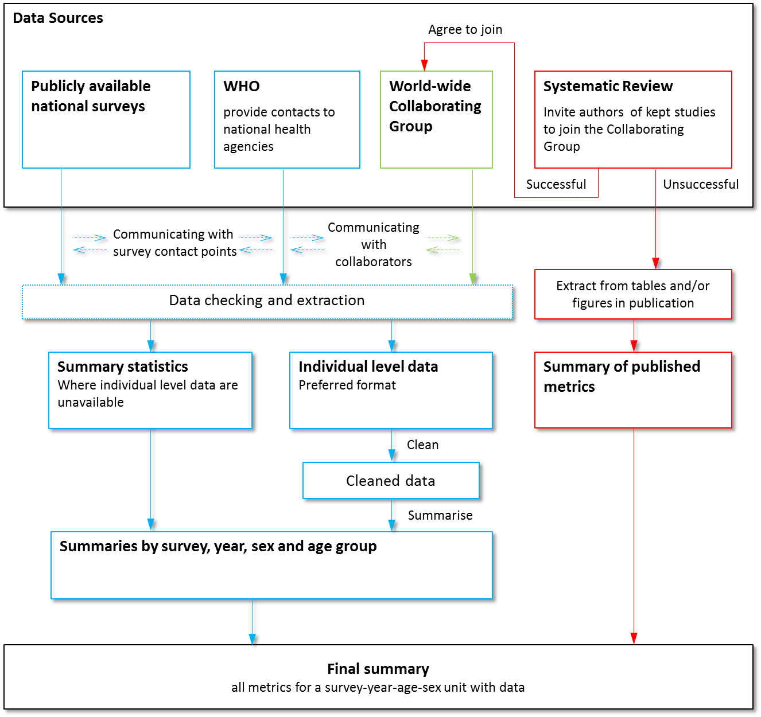
Figure 1. Flowchart of the data collation process.

Works cited
1. Global Burden of Metabolic Risk Factors for Chronic Diseases Collaboration. Cardiovascular disease, chronic kidney disease, and diabetes mortality burden of cardiometabolic risk factors from 1980 to 2010: a comparative risk assessment. Lancet Diabetes Endocrinol 2014; 2(8): 634-47.
2. GBD 2015 Risk Factors Collaborators. Global, regional, and national comparative risk assessment of 79 behavioural, environmental and occupational, and metabolic risks or clusters of risks, 1990-2015: a systematic analysis for the Global Burden of Disease Study 2015. Lancet 2016; 388(10053): 1659-724.
3. Global Burden of Disease Study Collaborators. Global, regional, and national incidence, prevalence, and years lived with disability for 301 acute and chronic diseases and injuries in 188 countries, 1990-2013: a systematic analysis for the Global Burden of Disease Study 2013. Lancet 2015; 386(9995): 743-800.
4. Pan SC, Ku CC, Kao D, Ezzati M, Fang CT, Lin HH. Effect of diabetes on tuberculosis control in 13 countries with high tuberculosis: a modelling study. Lancet Diabetes Endocrinol 2015; 3(5): 323-30.
5. World Health Organization. Global action plan for the prevention and control of noncommunicable diseases 2013-2020. 2013. http://apps.who.int/iris/bitstream/10665/94384/1/9789241506236_eng.pdf?ua=1 (accessed August 14 2015).
6. Zhou B, Bentham J, Di Cesare M, Bixby H, et al., on behalf of NCD Risk Factor Collaboration. Worldwide trends in blood pressure from 1975 to 2015: a pooled analysis of 1479 population-based measurement studies with 19.1 million participants. Lancet 2017; 389(10064): 37-55.
7. Zhou B, Lu Y, Hajifathalian K, Bentham J, et al., on behalf of NCD Risk Factor Collaboration. Worldwide trends in diabetes since 1980: a pooled analysis of 751 population-based studies with 4.4 million participants. Lancet 2016; 387(10027): 1513-30.
8. Danaei G, Fahimi S, Lu Y, Zhou B, et al., on behalf of NCD Risk Factor Collaboration. Effects of diabetes definition on global surveillance of diabetes prevalence and diagnosis: a pooled analysis of 96 population-based studies with 331,288 participants. Lancet Diabetes Endocrinol 2015; 3(8): 624-37.

Appendices

Appendix 1. Protocols of data cleaning for blood pressure and diabetes.

Appendix Table 1. List of data sources used in the blood pressure analysis.

Some of the contents in this chapter have been published in two papers in The Lancet.^{6,7}

